Lab - 5

Name: Jatvish Yechuri
Roll no : 36

DJANGO setup:

1. Create a python virtual env:

python3 -m venv myenv

2. activate:

source myenv/bin/activate

3. install django inside vm:

pip install django

Q1 Develop a simple web page to perform basic arithmetic operations. Take two integer
inputs from the user, select the operation to be performed using a dropdown. Include
a button “Calculate” to perform the selected operation, and then display the result
in the same web page.

Create a Django Project:

django-admin startproject Lab6

cd Lab6 // to navigate inside the dir

Create Django Apps:

python manage.py startapp arithmeticapp
python manage.py startapp magazineapp

Register Apps in settings.py(LabProject/settings.py):

INSTALLED_APPS = [
'django.contrib.admin',
'django.contrib.auth',
'django.contrib.contenttypes',
'django.contrib.sessions',
'django.contrib.messages',
'django.contrib.staticfiles',
'arithmeticapp',
'magazineapp',
]

Configure URLs(Lab6/urls.py):

from django.contrib import admin
from django.urls import path, include

urlpatterns = [
path('admin/', admin.site.urls),
path('arithmetic/', include('arithmeticapp.urls')),
path('magazine/', include('magazineapp.urls')),
]

views.py:

from django.shortcuts import render

def arithmetic_form(request):
result = None
if request.method == "POST":
num1 = float(request.POST.get("num1", 0))
num2 = float(request.POST.get("num2", 0))
operation = request.POST.get("operation")

if operation == "add":
result = num1 + num2
elif operation == "subtract":
result = num1 - num2
elif operation == "multiply":
result = num1 * num2
elif operation == "divide":
result = num1 / num2 if num2 != 0 else "Cannot divide by zero"

return render(request, 'index.html', {"result": result})

index.html:

<!DOCTYPE html>
<html>
<head>
<title>Arithmetic Operations</title>
</head>
<body>
<h2>Arithmetic Calculator</h2>
<form method="post">
{% csrf_token %}
Number 1: <input type="number" name="num1" required><br>
Number 2: <input type="number" name="num2" required><br>
Operation:
<select name="operation">
<option value="add">Addition (+)</option>
<option value="subtract">Subtraction (-)</option>
<option value="multiply">Multiplication (*)</option>
<option value="divide">Division (/)</option>
</select>
<br>
<button type="submit">Calculate</button>
</form>
{% if result is not None %}
<p>Result: {{ result }}</p>
{% endif %}
</body>
</html>

Screenshot:

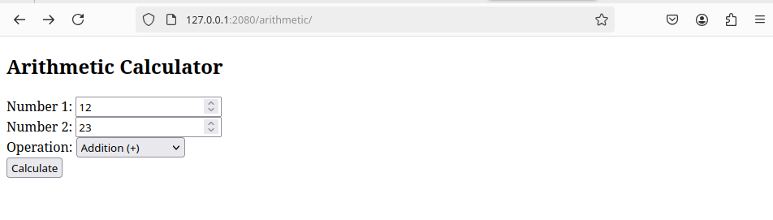

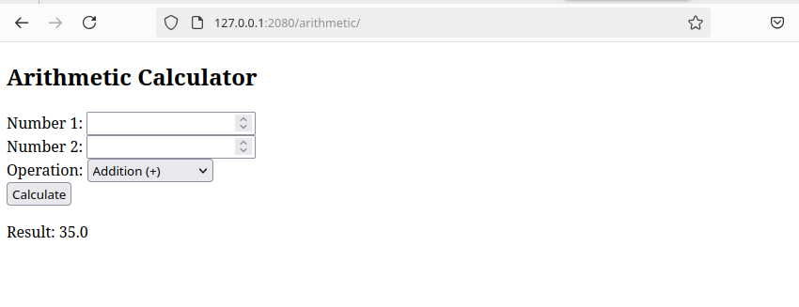

Q2) Develop a simple web form that generates the front cover for a magazine. The form
should provide the options for selecting the image, background color, changing font
size, color etc. Input messages must be taken from the user so as to display it on the
front cover with legible font family and font size. The front cover developed should
be proportionate to the web page size. Place the css files inside static folder.

urls.py:

from django.urls import path
from . import views

urlpatterns = [
path('', views.magazine_form, name='magazine_form'),
]

views.py:
from django.shortcuts import render

def magazine_form(request):
if request.method == "POST":
text = request.POST.get("text", "Magazine Title")
color = request.POST.get("color", "#000000")
bg_color = request.POST.get("bg_color", "#ffffff")
font_size = request.POST.get("font_size", "24px")

return render(request, 'magazine_form.html', {
"text": text,
"color": color,
"bg_color": bg_color,
"font_size": font_size,
"submitted": True
})

return render(request, 'index.html', {"submitted": False})

index.html:

<!DOCTYPE html>
<html>
<head>
<title>Magazine Cover Generator</title>
<style>
.cover {
width: 300px;
height: 400px;
text-align: center;
display: flex;
align-items: center;
justify-content: center;
font-family: Arial, sans-serif;
}
</style>
</head>
<body>
<h2>Magazine Cover Generator</h2>
<form method="post">
{% csrf_token %}
Title Text: <input type="text" name="text" required><br>
Text Color: <input type="color" name="color"><br>
Background Color: <input type="color" name="bg_color"><br>
Font Size: <select name="font_size">
<option value="16px">Small</option>
<option value="24px" selected>Medium</option>
<option value="32px">Large</option>
</select><br>
<button type="submit">Generate Cover</button>
</form>

{% if submitted %}
<h3>Generated Magazine Cover:</h3>
<div class="cover" style="background-color: {{ bg_color }};">
<p style="color: {{ color }}; font-size: {{ font_size }};">{{ text }}</p>
</div>
{% endif %}
</body>
</html>

screenshot:

